**Problem Statement 01**

Prerequisite : **Create a table with the schema as specified below and load the data.**

1. **Problem Statement 01 Prerequisite : Create a table with the schema as specified below and load the data.**

**Write a query to derive a new column extra_vacation based on the tenure served, the logic is as given below. 1. If tenure < 2, Then 20 2. If tenure is 2-10 then 30 days 3. If tenure > 10 then 40 days.**

**Problem Statement 02**

Prerequisite : **Create a table “temperature” to store the dataset as mentioned in the schema and load the data.**

**Write a query to calculate the maximum temperature of each state**

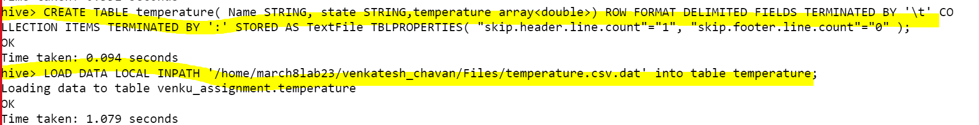

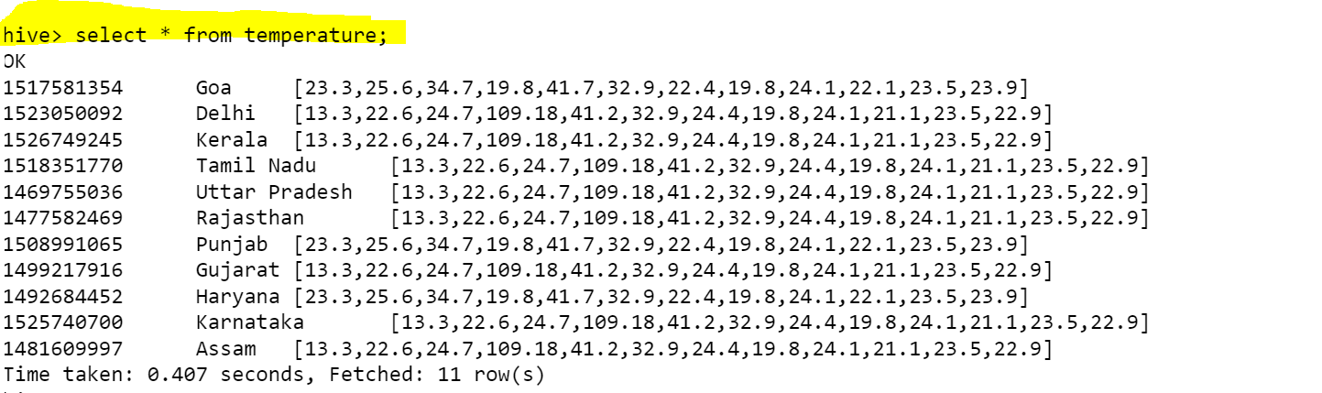

**Problem Statement 03**

**Prerequisite :**

**Create a table 'student_marks' with schema as shown above and load the data into the 'student_marks' table.**

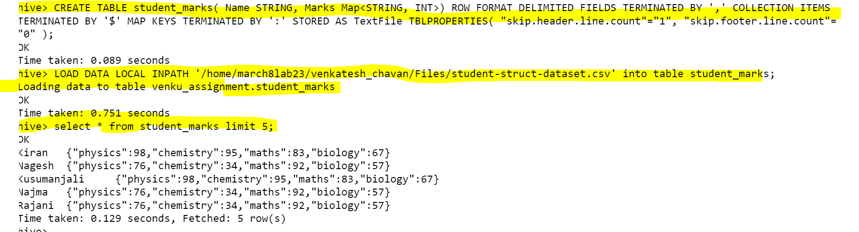

**Write a query to perform below mentioned tasks:**

1. Display NAME who have scored more than 90 in subject Maths subject

2.Display NAME and marks scored in physics subject.

3.Display NAME, and <Maximum-Subject-Marks>

4.Display NAME, and <average -Subject-Marks>

5)Display NAME and percentage of marks



**Problem Statement 04**

**Prerequisite :**

**Create a table “student_info” with schema as show below and load the data**

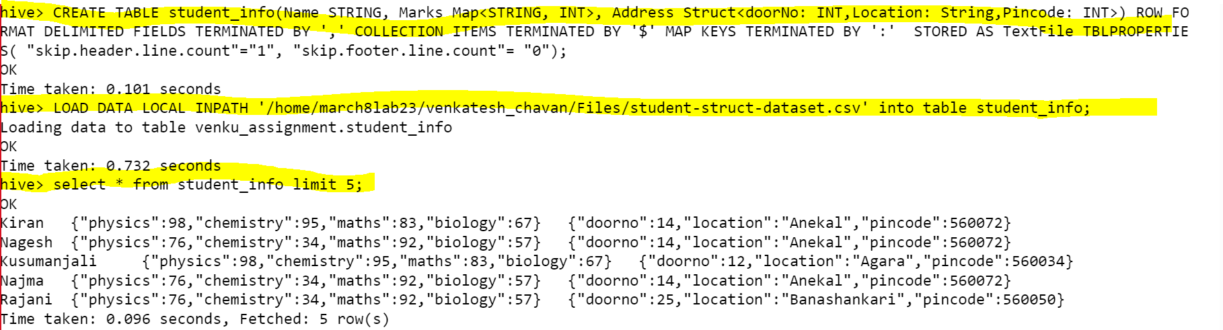

1)Display all “NAME” who is located in Banashankari



2)Calculate the total count who is staying in pin code 560001



